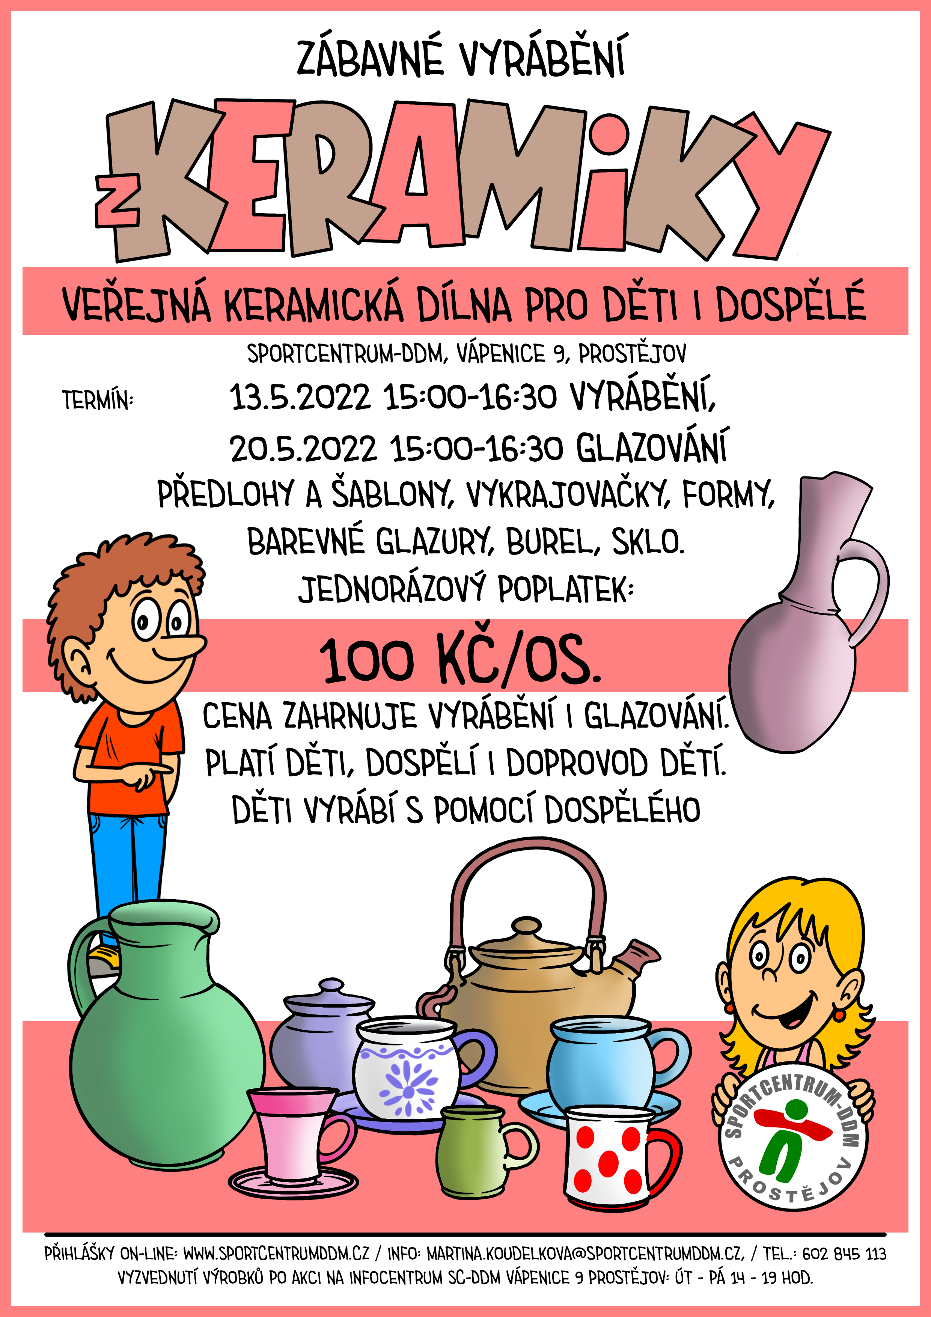

**18.5.2023 1)14–15 2) 15:30-16:30**

**11.5.2023 1)14–15 2) 15:30-16:30**